Crystal size and cooling rate: fast and slow cooling of lead iodide: teachers’ notes

Level
This activity is intended for students aged 11-14.

Topic
The activity relates to the process of igneous rock formation by the cooling of magma. It can be used to illustrate how the rate at which molten rock cools affects the size of the crystals that form within the solid rock – rapid cooling producing small crystals, slower cooling producing larger ones.

Description
Hot, saturated solutions of lead iodide are cooled at different rates. The solution that cools faster produces smaller crystals.

Context
Students need to be aware that igneous rock forms when magma cools and forms crystals. They should know from examining rock samples and / or photographs that igneous rock such as granite contains crystals and that different types of igneous rock contain crystals of different sizes.

Teaching points
The link that the students should be encouraged to make is that the intrusive igneous rock (the granite) has cooled slowly from magma, and the rhyolite lava (extrusive igneous rock) has cooled very quickly. This leads to a fuller explanation of the terms intrusive and extrusive – the intrusive rock has cooled slowly, at depth, where the overlying rocks have had an insulating effect. The extrusive rock has cooled quickly on the surface of the Earth, on land or on the ocean floor, and so crystals have little time to form and are therefore small. The time taken for cooling has had a direct observable effect on the physical appearance of the rock.
It is important to point out to students that they are looking at an analogy or a model – granite forms by crystallisation from a melt rather than from a saturated solution.
It is likely that the first tube (the one that cools at room temperature) will contain some undissolved lead iodide and students may object that this experiment is not a fair test. In fact the undissolved solute may tend to promote crystallisation by acting as seed crystals. Students could be encouraged to design (and, if time allows, carry out) a better experimental procedure in which they pour a little of the saturated solution into each of two boiling-tubes, leaving all the undissolved solid in the original tube to be discarded.

Timing
The activity takes about half an hour including about 15 minutes waiting for the solutions to cool.

The activity
Ask the students to compare a sample of granite with a sample of rhyolite. Alternatively, they can look at photographs, such as Figure 1 and Figure 2, if good samples are not available. Granite contains large crystals of the minerals feldspar, quartz and mica. The bulk of the rhyolite contains no obvious crystals, when seen in hand specimen. Challenge the students to speculate on the reasons for the obvious difference in crystal size.
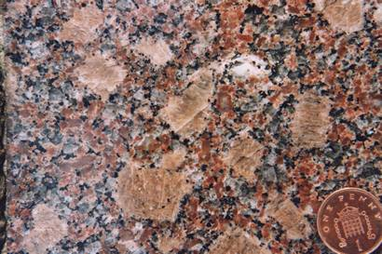
Figure 1 A sample of granite, note the large crystals
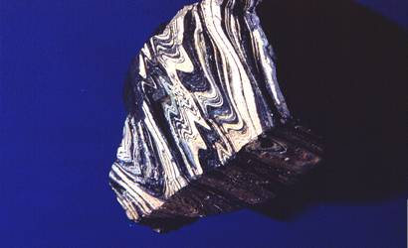
Figure 2 A sample of rhyolite - the crystals are too small to see. (The colour banding was produced as the sticky lava flowed over the ground)
Students carry out the following activity. Half fill a boiling-tube with water. Add a small spatula measure of lead iodide. Heat over a Bunsen flame, until the liquid starts to boil, taking care as the mixture can ‘bump’ very easily, spraying hot liquid out of the tube. Continue to boil for a further minute, then quickly tip half of the contents into another clean boiling-tube. Cool this second tube and contents immediately under a stream of cold water from the tap. Leave the original tube to cool down slowly.
Leave both boiling-tubes and contents for about 15 minutes, then inspect the contents. This allows the students some ‘writing up’ time. Both tubes need to be at the same temperature before they are compared.
The yellow lead iodide powder gradually goes into solution on heating. On rapid cooling, lead iodide falls out of solution quickly, with tiny sparkly flecks of crystals being formed. The solution that cools slowly produces distinctly larger crystals.

Apparatus
Each student or group will need
- eye protection
- 2 boiling-tubes
- boiling-tube rack
- Bunsen burner
- heatproof mat
- boiling-tube holder
- spatula
- thermometer (0-100 °C)

Chemicals
- a spatula measure of lead iodide (harmful by ingestion and inhalation of dust)
- samples of granite and of rhyolite (or photographs, see Figures 1 and 2, if samples are not available) - suitable specimens can be obtained from a geological supplier. Click here for details of some suppliers www.earthscienceeducation.com/suppliers.

Safety notes
- Wear eye protection.
- Lead iodide is harmful.
- It is the responsibility of the teacher to carry out an appropriate risk assessment.

Answers to questions
Q 1. The granite has the larger crystals.
Q 2. The crystals are larger in the tube that cooled more slowly, and smaller in the tube that cooled more quickly.
Q 3. The tube with the larger crystals cooled more slowly.
Q 4. Rhyolite cooled faster.
Q 5. Rock that cools underground (intrusive rock) will tend to cool more slowly than rock that cools on the surface (extrusive rock) because of the insulating effect of the rocks above it. Other sensible suggestions should be given credit.

Extension
An alternative practical activity that may be used to illustrate the effect of rate of cooling on crystal size is to cool molten salol (phenyl 2-hydroxybenzoate, phenyl salicylate) on microscope slides that are at different temperatures. (Safety note; salol presents a minimal hazard.)
In this experiment, salol is melted in a boiling-tube in a hot water bath. A few drops of the melt are placed, using a glass rod, onto two slides – one that has been cooled in a freezer and one that has been warmed in a water bath (and then dried). Each sample should immediately be covered by another slide at the same temperature. Once they have formed, the crystals can be observed using a hand lens, microscope or on an OHP, projection microscope or video microscope. The crystals that form on the cooled slide should be smaller than those on the warmed slide, see Figures 3 and 4.
This activity is a better analogy with crystallisation of magma than the lead iodide experiment, because it involves crystallisation from a melt. The activity is not, however, 100% reliable, partly because of supercooling of the salol which can delay crystallisation, and teachers may wish to try it out several times before doing it with a class. Some suggested tips for success include:
- Avoid overheating the salol – heat it only until it has just melted (42 °C).
- Once the slides have been removed from the freezer and water bath respectively, speed is essential to ensure that there is a significant difference in temperature between them once the salol is placed on them.
- Use another slide at the same temperature to cover the salol on the slides – this makes the rate of cooling more uniform and prevents crystals growing vertically upwards towards the observer thus appearing smaller in cross section than they actually are.

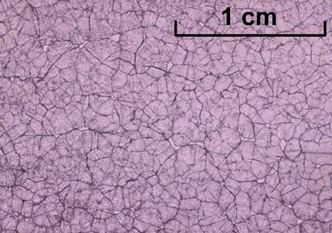
Figure 3 Small crystals of salol formed by rapid cooling
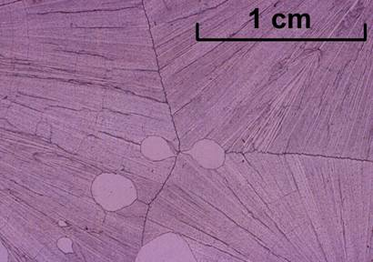
Figure 4 Large crystals of salol formed by slow cooling

