© Black Country Geodiversity Partnership
Funded by Defra's Aggregates Levy Sustainability Fund, administered by English Nature.

The contents of the Barr Beacon/Pinfold Lane pages on this website are the copyright of BCGP and reproduction is only permitted in accordance with the following terms:

You may view, download and print any material for non-commercial educational use, research or study.

Any commercial use requires the prior written permission of the Black Country Geodiversity Partnership.

Contact: geodiversity@btconnect.com

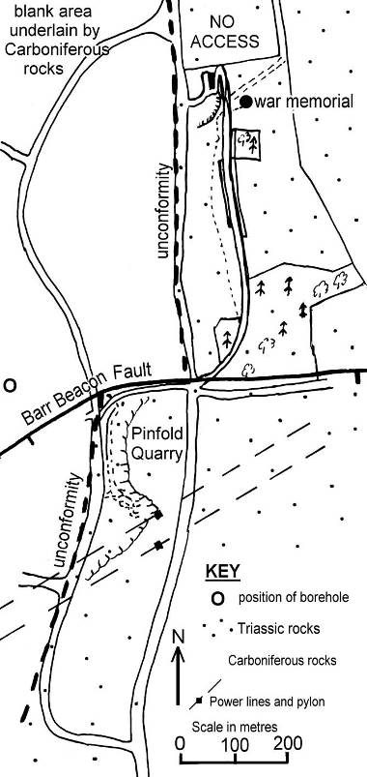
BARR BEACON, WALSALL, WEST MIDLANDS.

KS3 FIELD EXERCISES
© Black Country Geodiversity Partnership

WORKSHEET 1 Pupil Name …………………………………...

Site 1: Investigating the Barr Beacon War Memorial.

1. Mark your location as “site 1” on the map to the left.

2. Mark each of the other sites on the map as you come to them.

3. Investigate the materials used to make the different parts of the memorial, and how they are being weathered. Record your observations in the tables below.

4. On the diagram mark on the SW and NE sides of the sketch. Draw an arrow to show the direction of main wind (and rain).

 | Description of the material used | Reason it was used.
Roof | Sheets of copper. | Easily worked into sheets. Impermeable.
Columns | Limestone (Portland Limestone with fossils). | Strong, easily shaped and attractive colour.
Plinth | Blocks of red , bedded sandstone. | Small blocks easily cemented to together to form the plinth. Contrasting colour.
Wall | Limestone (Portland Limestone with fossils). | Easily shaped into blocks.  Matching colour with columns.
Surround | Flat blocks of grey sandstone. (Look closely at broken edges). | Hard wearing and easily shaped into flat pieces.
Ballustrade | Limestone (Portland Limestone). | Easily shaped. Matching colour.

 | Evidence of weathering Weathering type
Roof | Copper weathering to green malachite CuCO3. (Chemical)
Columns | Limestone weathered back to leave fossils proud of surface. (Chemical)
Surround | Cracks and uneven surfaces (Physical)
Ballustrade & steps | Fossils partly weathered out of matrix. (Chemical)  Vegetation growing in cracks. (Biological)

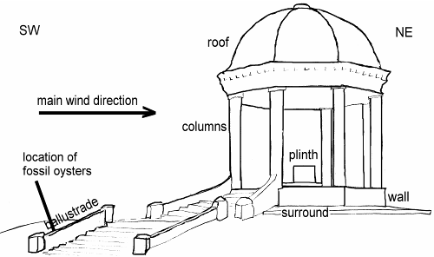
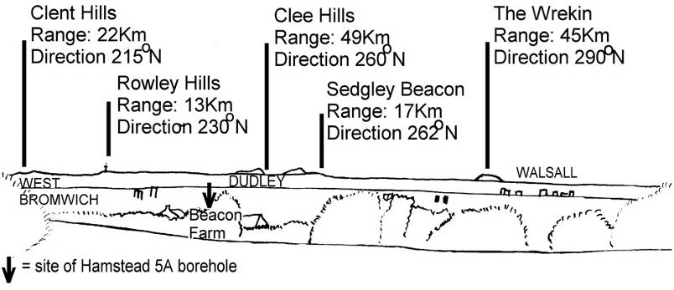
BARR BEACON, WALSALL, WEST MIDLANDS.

KS3 FIELD EXERCISES
© Black Country Geodiversity Partnership

WORKSHEET 2 Pupil Name …………………………………...

Site 2: The viewpoint to the SW.

- Estimate how far you can see today. _______________ km.

- Why are the hills higher than their surroundings?
They are made of rocks more resistant to weathering than the rocks under the lower ground.

Look at the towns to the SW. e.g. Walsall.  What natural raw materials have been used to create them?  Where did these materials come from? | House Roofs: Tiles from clay fired in a kiln. The clay is dug from the ground like slates - which are natural stones, not man made.  House walls (inside and out): Bricks from clay fired in a kiln. Inside will be plaster board made from gypsum or anhydrite.  Cement & concrete: sand, limestone, gypsum. Also clay and aggregate (stone fragments).  Windows: Pure silica sand melted and cooled rapidly to a glass.  Gas/oil for central heating: Drilled from oil traps and piped in. These fuels represent fossilised energy, created by organisms from sunlight, millions of years ago.  Roads and driveways: petroleum (oil) products like tarmac, mixed with stone fragments.  TV aerials, wires, garage doors, and cars: Metals smelted from metal ores.  Garden Soil: Formed when feldspars are chemically weathered to form clays. Soils are mixtures of naturally weathered products including sand and clay, plus some organic material.  Grass and trees: Grow in soil. (Also use gasses from the atmosphere and sunlight).  All of these products have their origins in the ground, either quarried or mined, or are growing in it.

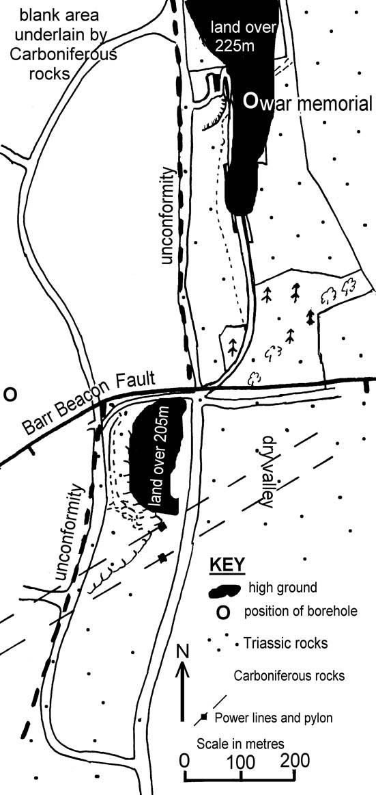
BARR BEACON, WALSALL, WEST MIDLANDS.

KS3 FIELD EXERCISES
© Black Country Geodiversity Partnership

WORKSHEET 3 Pupil Name …………………………………...

Site 3: The Viewpoint To The South.
- Mark your position, site 3 on the map.

- What feature is marked on the map running from east to west near your position?

The Barr Beacon fault

- You have been walking along the Barr Beacon Ridge, but in front of you is a valley. What has happened to the ridge? (Hint: Look at the dark areas on the map)

The higher ground south of the fault is away to the right (west). This is caused by the fault.

- Describe the river valley in front of you.

Gentle slopes, straight valley. No river.

5. Why is there no river in the bottom of this valley?
Rain water percolates through the soil and into the rock below.

6. Look at the soil you are standing on. Describe it.
It is very sandy with rounded pebbles in it. When water is poured onto it, it soaks in very quickly, so it is porous and permeable.

7. Can you suggest what differences there must have been either to the climate, or the permeability of the soil when the river cut this valley in the past?
Either the climate was wetter, so there was enough water to fill the river, or the permeability must have been less in the past. (Due to being frozen solid after the Ice Age, whilst melt water flowed over the surface).

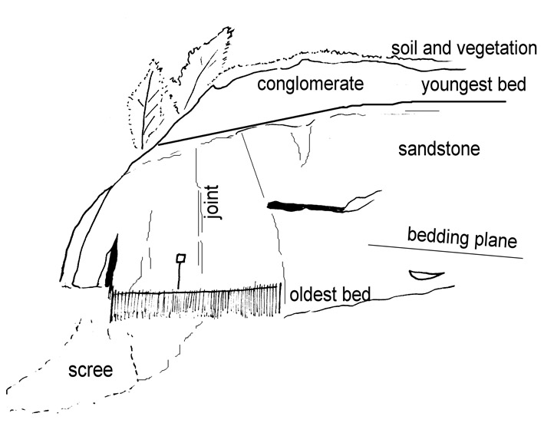
BARR BEACON, WALSALL, WEST MIDLANDS.

KS3 FIELD EXERCISES
© Black Country Geodiversity Partnership

WORKSHEET 4 Pupil Name …………………………………...

Site 4: A Study Of The Boundary Wall
Inspect the dark blocks in the wall along the pavement near the Barr Beacon entrance. Describe the rock that forms these blocks using the table below to help you.

What colour are these blocks? Black

Do the blocks contain fossils? No

Do they show bedding planes? No

Are they made up of Yes
interlocking crystals?

Is the rock made up of coarse Medium to Fine
Medium or fine pieces?

What kind of rock is it? Igneous

Site 5: Field Sketch of Pinfold Quarry.

On the sketch label the following features.

- joint plane 5. youngest bed
- bedding plane 6. soil & vegetation
- scree 7. conglomerate
- oldest bed 8. sandstone

Draw in one or two bedding planes on the lower right side of the face.

BARR BEACON, WALSALL, WEST MIDLANDS.

KS3 FIELD EXERCISES
© Black Country Geodiversity Partnership

WORKSHEET 5 Pupil Name …………………………………...

Site 5a. Pinfold Quarry Pebble Study

1. PEBBLE SHAPE INVESTIGATION.
Use the diagram on the right to help you describe the rounding of theses pebbles.

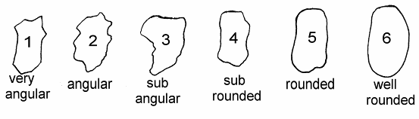
The shape of most of the pebbles is _______well rounded_____________

- PEBBLE-TYPE INVESTIGATION.
Drop a marker, such as a pen, on the scree and pick the 20 pebbles touching it. Use the pebble sheet to help you identify them and record the frequency of pebble types below. Then graph your results on the right.

VEIN QUARTZ | IGNEOUS | META-MORPHIC | SEDIMENTARY | DON’T  KNOW
Your results  Total = | Total = | Total = | Total = | Total =
All results.  Total = | Total = | Total = | Total = | Total =

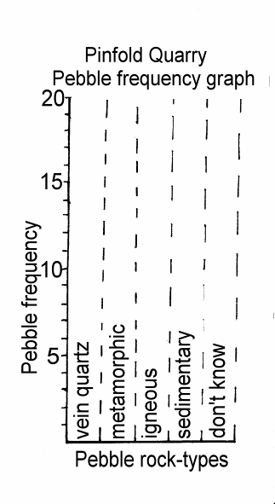
- SUMMARY OF TWO ROCK CYCLES.

Most of these pebbles are _well rounded___ in shape. The two most common pebble types are ____white quartz___ and _grey quartzite____. They are found on the scree because they have been _weathered ____ from the quarry face above. The sedimentary pebbles, like conglomerate / sandstone, tell us that there was an_earlier___ rock cycle, when these rocks were __weathered___ from their ancient outcrop and transported here. The largest pebble we found is __(200)_mm across, and suggests a flow of _____400____ cm per second when it was deposited in the Triassic period 245 __million____ years ago. These pebbles must have been in at least __two___ rock Cycles.

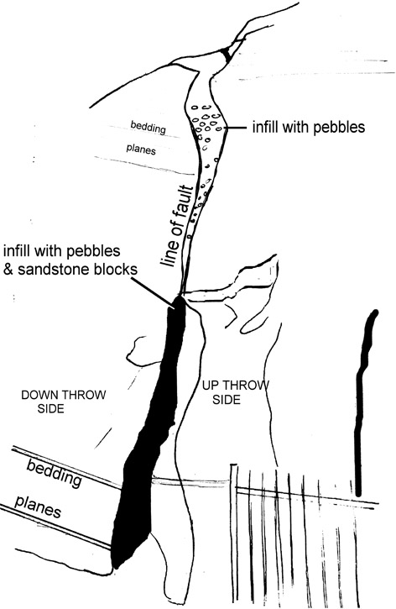
BARR BEACON, WALSALL, WEST MIDLANDS.

KS3 FIELD EXERCISES
© Black Country Geodiversity Partnership

WORKSHEET 6 Pupil Name …………………………………...

1. Sketch the break in the rocks in the space below

2. On your sketch mark on the following:

a: bedding planes;

b: fault plane;

c: fault plane in filled with pebbles;

d: down throw side and up throw side.

COMPARISON OF THE ROCK AT SITE 5b WITH QUARTZITE.

Feature | Sandstone. | Quartzite.
What colour is the rock? | Red | Grey
Is it porous and permeable? | Yes and Yes | No and No
Which is denser (Feels heavier for its size) | Feels lighter (less dense) | Feels heavier (more dense)
Does it have bedding planes? | Yes | Some pebbles might, but not clear ones.
Which has cemented grains and which has interlocking crystals? | Cemented grains | Interlocking crystals
Which is stronger (soft) and which is harder? | Softer | Harder

BARR BEACON, WALSALL, WEST MIDLANDS.

KS3 FIELD EXERCISES
© Black Country Geodiversity Partnership

WORKSHEET 7 Pupil Name …………………………………...

Summary Of Events At Barr Beacon Nature Reserve.

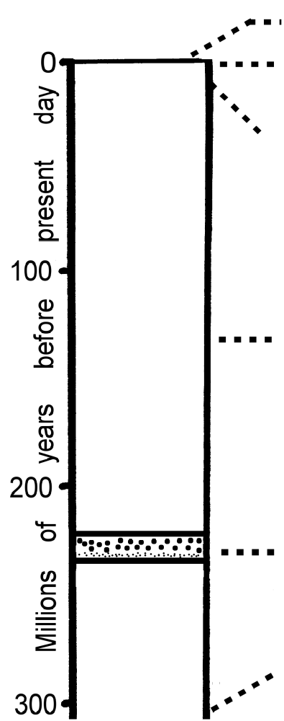
Write each of the sentences below in the correct box in the summary column above:
- A very long period when faulting, weathering and erosion occurred.
- Deposition of the sandstone in a desert environment.
- Transport by large rivers & deposition of rounded pebbles to form conglomerates.
- Quarrying of the rocks for aggregates (sand & gravel)
- Erosion of pebbles to form scree in the quarry
- Erosion of dry valleys by rivers now dried up.
- Deposition of coal and other rocks before the Triassic period began.

Erosion of pebbles to form scree in the quarry.

Quarrying of the rocks for aggregates (sand & gravel).

Erosion of dry valleys by rivers now dried up.

A very long period when faulting, weathering and erosion occurred.

Transport by large rivers & deposition of rounded pebbles to form conglomerates.

Deposition of coal and other rocks before the Triassic period began.

Deposition of the sandstone in a desert environment.

BARR BEACON, WALSALL, WEST MIDLANDS.

KS3 FIELD EXERCISES
© Black Country Geodiversity Partnership

WORKSHEET 8 Pupil Name …………………………………...

PUPIL HOMEWORKSHEET: The Two Rock Cycles at Barr Beacon.

FIRST CYCLE: deposition. What can you say about the deposition of the beds you have seen [The Hopwas Breccia and Kidderminster Conglomerate]?

The sandstone was deposited first by currents flowing from the SW. The sand contains pebbles up to 2cm across which are sub angular, suggesting they were not transported too far.

The conglomerate lying on top has very large rounded pebbles suggesting the currents became much more powerful. Both beds are coloured red suggesting deposition was in an arid climate causing the iron to be oxidised.
The pressure marks on the pebbles suggest they were then deeply buried under later rocks.

FIRST CYCLE: uplift and tilting. What can you say about the changes to the beds cause by plate tectonics? HINTS: tilting and faulting..

The beds are now over 200 metres above sea level and so must have been uplifted.
The beds have been tilted to the east (by about 10⁰). They have also been faulted by the Barr Beacon Fault and a smaller fault in Pinfold Quarry.

SECOND CYCLE: weathering and erosion. What evidence of present day weathering and erosion have you seen? HINTS: screes, vegetation, memorial etc.

The memorial has been weathered so that the copper has turned into green carbonate (malachite). The fine material in the limestone pillars have also been weathered to let the fossils stick out from the rock. This has been caused by rain and wind from the SW. The soil in Barr Beacon is full of pebbles, and the scree in Pinfold Quarry has many pebbles, also weathered from the conglomerate. The roots of trees growing into the Quarry will also break up the rock.

SECOND CYCLE: sediment transport. What evidence have you seen for weathered sediments being transported?

In Pinfold Quarry the pebbles have fallen onto the scree. There are also signs of rain wash gullying the faces and washing material onto the quarry floor.

